Section I
Total Marks (75)

Part A
Total marks (15)
Attempt Questions 1-15
Allow about 30 minutes for this part

INSTRUCTIONS
Use the multiple choice answer sheet on page 5


1. When equal volumes of 0.10 mol L ^{–1} HCl and NaOH are mixed in a calorimeter and a temperature rise is
observed. Which equation explains the observation?

(A) H ⁺_{(aq)} + H₂O _{(l)} → H₃O ⁺_{(aq)} ∆H = – 57.9 kJ mol ^{–1}
(B) NaCl _{(aq)} → Na⁺_{(aq)} + Cl –_{(aq)} ∆H = + 57.9 kJ mol ^{–1}
(C) H ⁺_{(aq)} + OH –_{(aq)} → H₂O _{(l)} ∆H = – 57.9 kJ mol ^{–1}
(D) HCl _{(aq)} → H ⁺_{(aq)} + Cl –_{(aq)} ∆H = + 57.9 kJ mol ^{–1}

Answer – (C)
Outcome – H7

2. Which set shows the degree of ionisation of acetic, citric and hydrochloric acids?

(A) acetic < citric < hydrochloric
(B) hydrochloric > acetic > citric
(C) hydrochloric < citric < acetic
(D) citric < hydrochloric < acetic

Answer – (A)
Outcome – H8

3. An HCl solution is diluted with water increasing its volume by ten–fold.
Which change does not occur as result of this dilution?

(A) [H ⁺] decreases ten–fold.
(B) pH decreases by ten units.
(C) [OH –] increases ten–fold.
(D) pH increases by one unit.

Answer – (B)
Outcome – H10

4.The first step in the gravimetric analysis of the sulfate content of lawn fertiliser involves the precipitation.
Which solution will precipitate sulfate?

(A) NaOH
(B) H₂SO₄
(C) NH₃
(D) BaCl₂

Answer – (D)
Outcome – H8, 11

5.Which species is the conjugate acid of PO₄ ^{3–} ?

(A) H₃PO₄
(B) H₂PO₄ –
(C) HPO₄ ²⁻
(D) PO₃ ^{3–}

Answer – (C)
Outcome – H8

6. Which term describes the relationship between the compounds below?

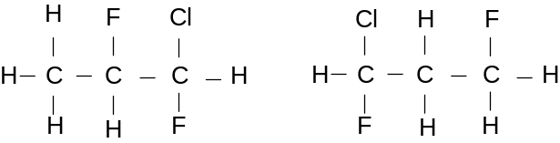

(A) Monomers
(B) Isotopes
(C) Isomers
(D) Allotropes

Ans: C
Outcome(s): H9

7. What is the purpose of adding Fe³⁺ salts in the process of water treatment?

(A) to increase tooth hardness
(B) to disinfect the water
(C) to lower the acidity of the water
(D) to coagulate fine particles to improve effective filtering

Ans: D
Outcome(s): H4, H8

8. Which of the following methods best determines the total dissolved solids in a water sample?

(A) AAS
(B) electrical conductivity
(C) a pH meter
(D) a flame test

Ans: B
Outcome(s): H4, H1

9. Which of the following is NOT a use for ethylene?

(A) as a monomer for the manufacture of plastics
(B) as a source of ethanoic acid
(C) as a source of ethylene glycol
(D) as a fuel in power plants

Ans: D
Outcome(s) H16

10. Why is ethylene readily transformed into many useful products?

(A) due to its high percentage carbon content
(B) due to the presence of a double bond
(C) due to its low boiling point
(D) due to its triple bond

Ans B
Outcome(s):H8, H9

11. Which of the following pairs of monomers are NOT likely to react by condensation polymerisation?

(A) 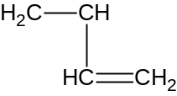 and 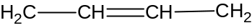

(B) and 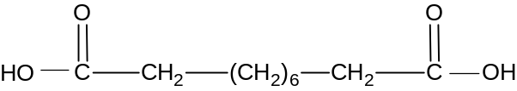

(C) and 

(D) and

Ans: A
Outcome(s) H9, H13

12. Which of the following is a catalyst used for the production of ethanol from ethylene.?

(A) concentrated H₃PO₄
(B) dilute sulfuric acid
(C) yeast
(D) concentrated H₂SO₄

Ans:B
Outcome(s) H9

13. Given the following results of an experiment:
Test | Metal X | Metal L | Metal Z
acid | rapid effervescence:  metal dissolves quickly | bubbles slowly form on surface; rate increases on heating | some bubbles of gas form on surface

Which of the following reactions will not occur?
(A) XCl₂(aq) + L (s) → LCl₂ (aq) + X(s)
(B) LCl₂(aq) + X (s) → XCl₂ (aq) + L(s)
(C) ZCl₂(aq) + X (s) → XCl₂ (aq) + Z(s)
(D) ZCl₂(aq) + L (s) → LCl₂ (aq) + Z(s)

Ans: A
Outcome(s): H13

14. . In which of the following transformations is the underlined species undergoing reduction.?

(A) MnO₄⁻ -→ Mn²⁺
(B) Cr₂O₇²⁻ → CrO₄²⁻
(C) H₂O₂ → O₂
(D) SO₂ → SO₃

Ans: A
Outcome(s): H6,H13

15.Which of the following transuranic syntheses is made to occur in a nuclear reactor?

(A) 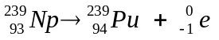

(B) 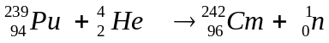

(C) 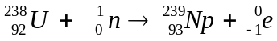

(D) 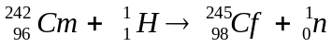

Ans C
Outcome(s): H6

Student Number …………………………

Section A Mark -----/15

Multiple Choice Answer Sheet

1. A  B  C  D 

2. A  B  C  D 

3. A  B  C  D 

4. A  B  C  D 

5. A  B  C  D 

6. A  B  C  D 

7. A  B  C  D 

8. A  B  C  D 

9. A  B  C  D 

10. A  B  C  D 

11. A  B  C  D 

12. A  B  C  D 

13 A  B  C  D 

14. A  B  C  D 

15. A  B  C  D 

JAMES RUSE AGRICULTURAL HIGH SCHOOL
2005 CHEMISTRY TRIAL HSC EXAM Student Number …………………………

Section I (continued)

Part B - 60 marks
Attempt Questions 16 -29
Allow about 1 hour and 45 minutes for this part

Answer the questions in the spaces provided
Show all relevant working in questions involving calculations

Question 16 (3 marks) MARKS

Assess the impact of atomic absorption spectroscopy on the scientific understanding of the
effects of trace elements. 3

Outcome – H4

Trace elements are essential for the growth, health and nutrition of humans, livestock and crops. (1 mark)

They are termed ‘trace’ elements because their required levels for nutrition are exceedingly minute. (1 mark)

Prior to the widespread use of AAS, trace element studies were severely limited. The supreme sensitivity, selectivity and accuracy of AAS (1 mark) was instrumental (pun intended) in measuring the concentrations of metallic trace elements which were essential for the health of humans and the quality of the food supply they consumed.

Question 17 (5 marks)

Jack and his lab partner Jill are given a prac test where they must prove that a sample solution
contains barium, copper and lead ions. The flow chart shows the test method they followed…

Test Solution

Ba²⁺ Cu²⁺ Pb²⁺
Step 1
Addition of Cl –

Precipitate X
Step 2
Addition of SO₄^{2–}

Precipitate Y
Step 3
Addition of OH –

Precipitate Z

(a) Write ionic equations showing the formation of precipitates X, Y and Z. 3

(X) ______________________________________________________________

(Y) ______________________________________________________________

(Z) ______________________________________________________________

(X) Pb²⁺_{(aq)} + 2Cl –_{(aq)} → PbCl₂ _{(s)}

(Y) Ba²⁺_{(aq)} + SO₄^{2–}_{(aq)} → BaSO₄ _{(s)}

(Z) Cu²⁺_{(aq)} + 2OH –_{(aq)} → Cu(OH)₂ _{(s)}

Outcome – H8

(b) What problem would occur if the sequence was changed by adding SO₄^{2–} in Step 1
and Cl – in Step 2? 1

Both Pb²⁺ and Ba²⁺ would precipitate simultaneously as white solids, PbSO₄ and BaSO₄.
Thus, their presence could not be independently verified.

Outcome – H11

(c) Jill suggests that the test procedure could be simplified by performing flame tests on the
original test solution proving the presence of Ba²⁺ and Cu²⁺.

Comment on the validity of Jill’s suggestion 1

Jill’s suggestion is invalid. If a flame test was performed on the original test solution, barium and copper would simultaneously produce yellowish–green and bluish–green light which would blend and become indistinguishable.

Outcome – H11, 14

Question 18 (4 marks)

(a) Ammonium sulfate is commonly used as a lawn fertiliser.
Calculate the mass percentage of sulfate in (NH₄)₂SO₄. 1

Percentage sulfate = M _{sulfate} ÷ M _{ammonium sulfate} = 96.07 ÷ 132.154 = 72.70% (1 mark)

Outcome – H10

MARKS

(b) Three high schools perform a sulfate analysis of ammonium sulfate by precipitating
the sulfate followed by filtration. The schools’ results were…

School | Filtration Method | Student’s Comments | Mean Sulfate %
Avogadro H.S. | Sintered glass crucible was used. | “The filtration was very quick using a vacuum pump.”  “The filtrate was slightly cloudy”. | 63.9
Le Châtelier H.S. | 1% agar solution was used as a coagulating agent. Normal filter paper was used. | “The mixture filtered quickly at first, then slowed down.”  “The filtrate was clear.” | 76.3
Haber H.S. | Fine grade filter paper was used. | “The filtering took a long time.”  “The filtrate was milky.” | 58.2

Evaluate the validity of each school’s experimental results. 3

Avogadro’s and Haber’s results were demonstrably invalid since their filtrates were unclear indicating the passage of BaSO₄ through the filter. (1 mark)

Le Châtelier’s results were valid because their filtrate was clear and their sulfate % closely matched the expected result (72.70%). (1 mark)

► If the answer is justified only on the closeness to the theoretical result = 1 mark

Outcome – H11, 14

Question 19 (5 marks)

(a) Write a balanced chemical equation showing citric acid ionising in water by donating a
proton to a water molecule. 1

C₆H₈O₇ _{(s)} + H₂O _{(l)}  C₆H₇O₇–_{(aq)} + H₃O ⁺_{(aq)}

Outcome – H8

(b) Write the formula of the conjugate base of citric acid. 1

C₆H₇O₇–

Outcome – H8

(c) Citric acid and acetic acid are common food additives. Explain their use. 2

Weak acids such as citric and acetic are commonly used as acidulants which lower the pH and increase tartness. They also are used as food preservatives since harmful micro-organisms cannot survive low pH environments.

Citing a use. (1 mark)
Explanation of acidic effect. (1 mark)

Outcome – H4

(d) A student analyses the amount of citric acid present in orange juice by titration with
standardised NaOH. Suggest a suitable indicator for this titration 1

Phenolphthalein. (1 mark)

Outcome – H11

Question 20 (6 marks)

(a) Identify whether the salt, sodium hydrogen carbonate is acidic, basic or neutral.
Write a balanced equation to explain its acidic, basic or neutral nature in water. 2

NaHCO₃ is a basic salt. (1 mark)

Na⁺ + HCO₃– + H₂O → Na⁺ + H₂CO₃ + OH – (1 mark)

Outcome – H8

(b) The hydrogen carbonate ion is amphiprotic.
Write two balanced equations showing the hydrogen carbonate ion acting as a
Brønsted–Lowry acid and as a base 2

Acting as an acid… HCO₃– + OH – → H₂O + CO₃^{2–} (1 mark) ► Four species must be shown.

Acting as a base… HCO₃– + H₃O – → H₂CO₃ + H₂O (1 mark)

Outcome – H8

(c) The hydrogen carbonate ion acts as part of a buffer solution in the blood and in fresh and salt
water. Describe the effect that buffers have in these natural systems. 2

Buffers stabilise the pH of the system (1 mark) by reacting with an influx of acid or base. (1 mark)

Outcome – H8

MARKS
Question 21 (3 marks)

A sample of acidic industrial effluent was titrated with standardised 0.100 mol L ^{– 1} NaOH.
A pH electrode connected to a data logger was used to monitor the titration.

The table and incomplete graph show the data collected, i.e. volume of NaOH added and resultant pH of titration mixture…

mL NaOH | pH | mL NaOH | pH | mL NaOH | pH
0 | 4.3 | 14 | 7.6 | 28 | 11.7
2 | 5.7 | 16 | 7.7 | 30 | 11.9
4 | 6.4 | 18 | 7.8 | 32 | 12.1
6 | 6.8 | 20 | 8.0 | 34 | 12.2
8 | 7.1 | 22 | 8.5 | 36 | 12.3
10 | 7.3 | 24 | 10.7 | 38 | 12.3
12 | 7.5 | 26 | 11.3 | 40 | 12.3

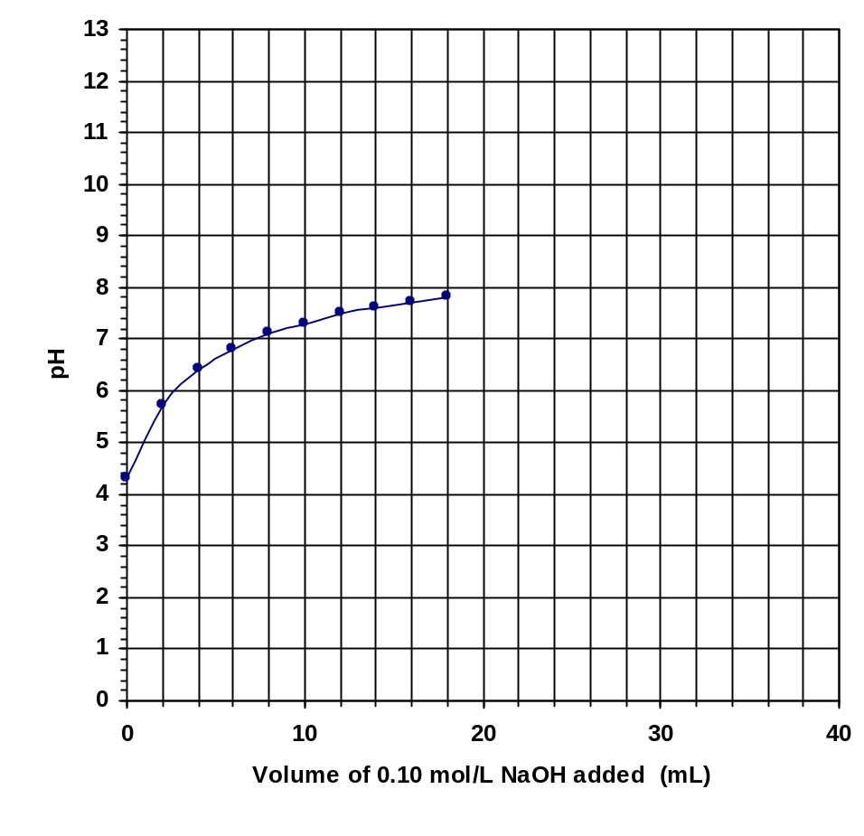

Question 21 continues next page

MARKS
(a) The first ten data points on the graph are plotted. Plot the remaining eleven data points
and complete the line of best fit. 1
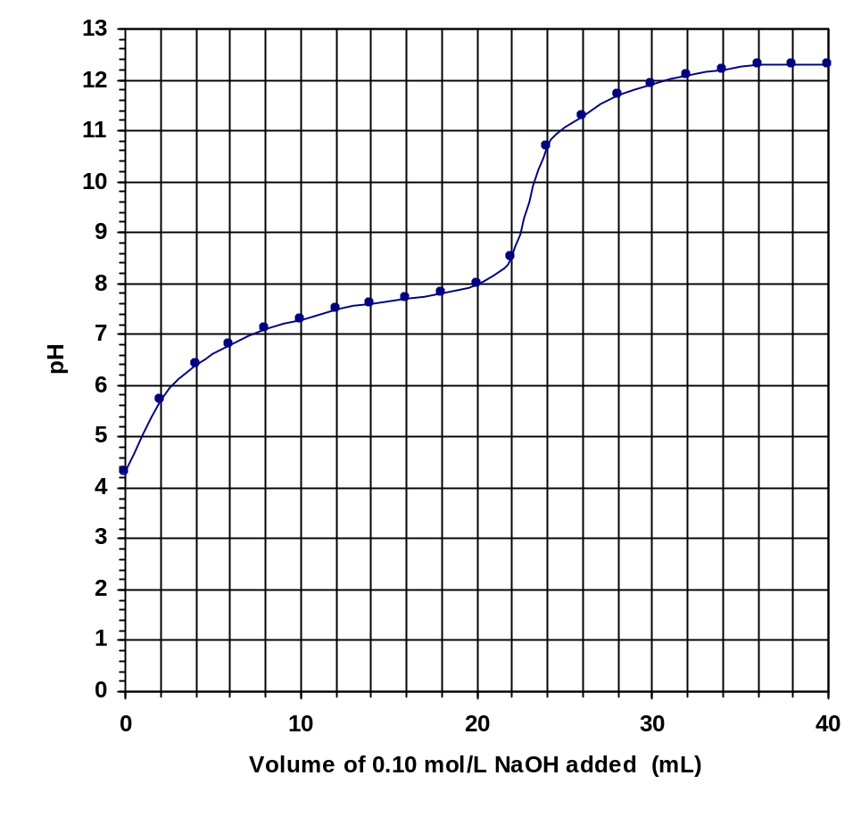

Correctly plotted data and completed curve. (1 mark)

Outcome – H13

(b) Estimate the pH of the neutralisation point by interpolation. 1

pH 9.6 (1 mark)

Outcome – H10

(c) This titration could be performed using an indicator rather than a pH electrode.
Identify a suitable indicator. 1

Phenolphthalein (1 mark)
Outcome – H10
MARKS

Question 22 (6 marks)

(a) Draw a labelled diagram of a galvanic cell consisting of a tin electrode in a solution of
tin(II)chloride and zinc electrode in a solution of zinc sulfate. . 1

(b) In the diagram;
(i) label the anode and the cathode. 1
(ii) indicate the direction of the electron flow 1

Outcome(s) H14,H13,H8
Possible Answer

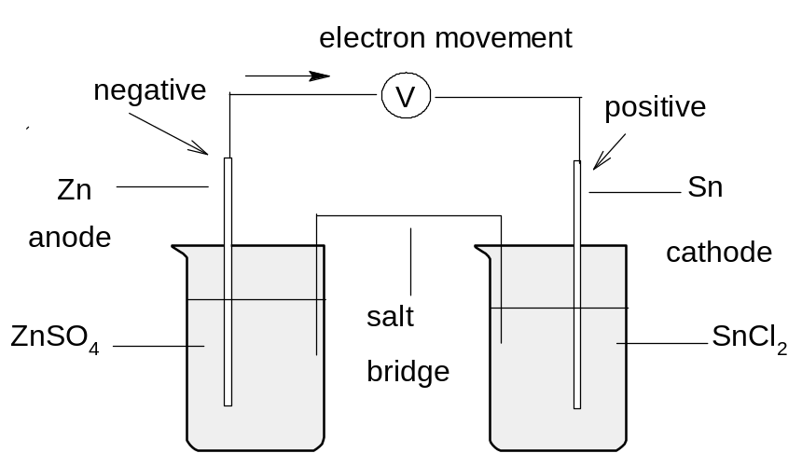

Marking Scheme:
(a) neat diagram indicating salt bridge 1 mark
electrodes and electrolytes
(b) labels for anode and cathode 1 mark
direction of flow of electrons 1 mark

(c) Calculate the expected voltage of this cell. 1

Expected voltage of cell = E₀ cathode - E₀ anode = -0.14 – (-0.76) = + 0.62 volts (1 mark)

(d) Write the net ionic equation for the cathode reaction. 1

………………………………………………………………………………………………………

Sn²⁺ + 2e⁻ → Sn(s) (1 mark for the balanced equation including phase label)

(e) When this cell was constructed by a group of Year 12 students, they obtained a smaller
than expected voltage. Explain their observation. 1

The experiment may not have been conducted under standard conditions of 1molL⁻¹ electrolyte
concentrations , 25⁰C temperature and 1 atm pressure. . Moreover, the voltmeter while measuring
potential, also uses current and hence, changes the potential it is measuring.

Question 23 (7 marks)

Outcome(s) H8, H9,H10, H11,H13

(a) Write a balanced formula equation for the fermentation of glucose to ethanol. 1

(a) C₆H₁₂O₆ (aq) 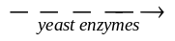 2 C₂H₅OH (aq) + 2 CO₂(g)

The equation must be balanced and should involve glucose (not sucrose).

(b) Other than temperature, identify one condition which promotes fermentation of sugars 1

Other conditions needed for fermentation are the presence of yeast , phosphates, absence of oxygen.
One answer will suffice.

(c).Using the equipment shown below, plan a first hand investigation to determine the
effect of initial temperature on the rate of fermentation of glucose.

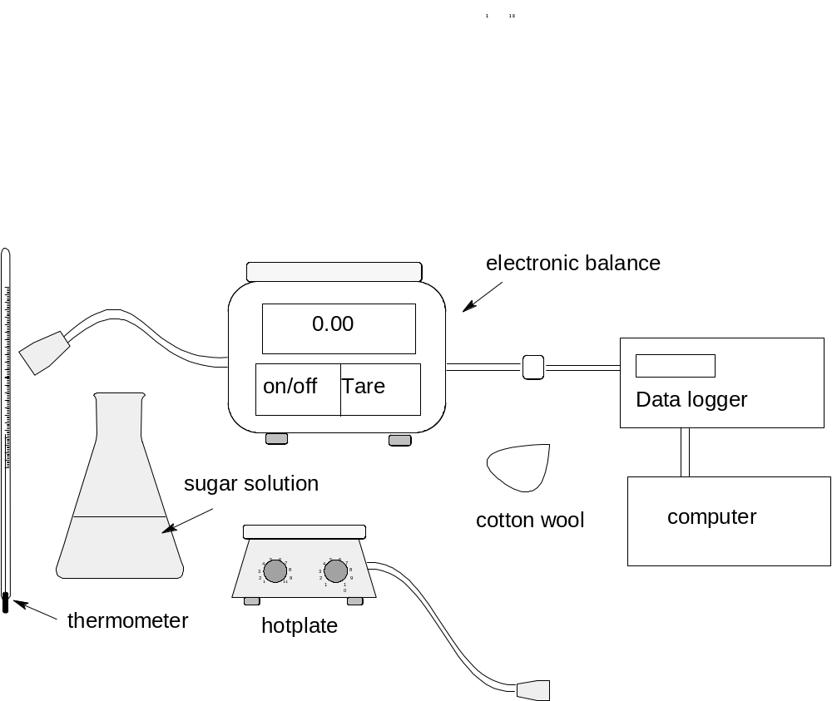

(i) The effect of temperature on the rate of fermentation of glucose..

1.Set-up two identical conical flasks(same type and capacity) containing exactly the
- same amount of glucose, yeast, water,
- same amount of cotton wool in the plug (1 mark)

2. The fermentation in the flask is initiated using two different temperatures. A thermometer is used to
measure the initial temperature for each flask (1 mark)

3. The progress of the fermentation is monitored by placing the flask on an electronic top loading balance
which is interfaced with a data logger and a computer. (1 mark)

4. A series of readings of mass against time is obtained. When the data is plotted, the flask initiated with
the temperature closest to 40⁰C will have a higher initial negative slope than the one with the lower temperature.

Diagram of the set-up: (Suggested set-up)
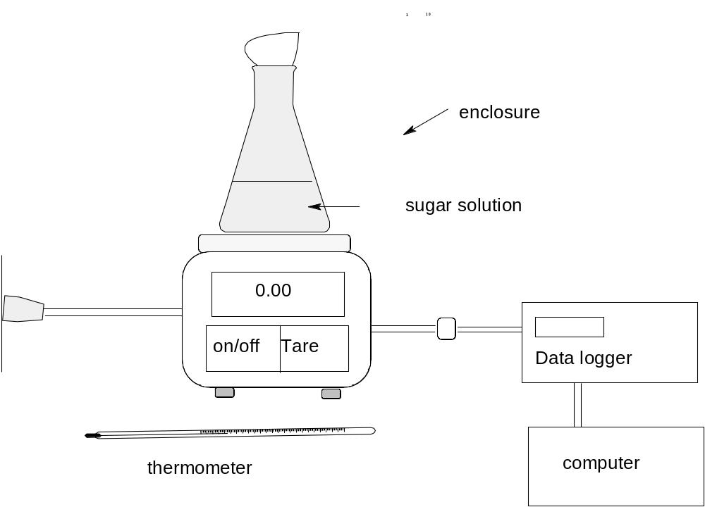

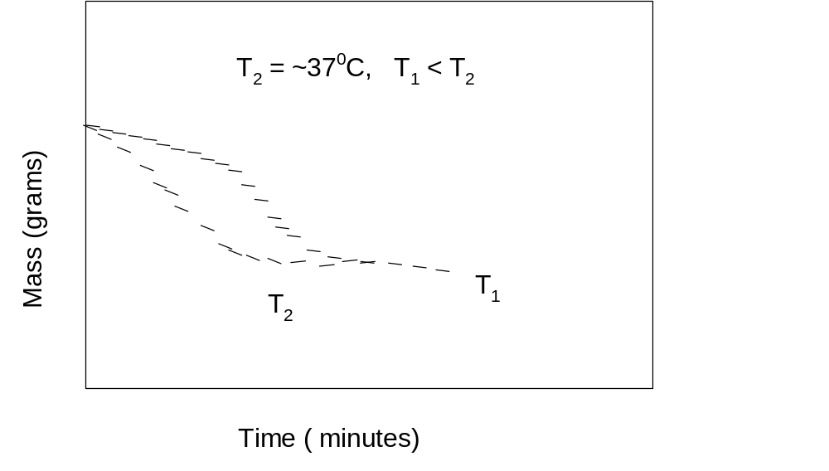
Question 24. (1 mark)

Describe one everyday use of indicators. 1

Outcomes: H13
Possible answer:
Indicators have a variety of uses in everyday life (any of the following)
- used to test soil pH to determine suitability of soil for a particular crop
- used to test swimming pool water to ensure that the water will not irritate the skin
- used to test aquarium water to ensure that the water is favourable to aquatic life

Question 25 (5 marks)

Assess the evidence which indicates increases in atmospheric concentration of oxides of
sulfur and nitrogen 5

Outcomes:H4,H14, H16
Possible answer:

Evidence:
- observed increase in the area experiencing acid rain,
- noticeable increasing degradation of marble structures in most places,
- higher prevalence of photochemical smog in urban areas
- higher death rate from respiratory illness in cities compared with rural areas

Origin of acidic oxides
- generated mainly by industrial activities in power plants,
- high temperature combustion engines
- and metal ore smelting facilities..
These are local activities that tend to increase the concentration of these oxides in those local areas and hence damage air from those areas. However, air shifts freely from place to place and from country to country so that any increase in one country tends to be felt in a neighbouring country . The precipitation of these oxides as sulfates and nitrates tend to reduce their concentration in the atmosphere but surface as acid rain.
Assessment of the Evidence
The evidence for this increase is based on visual (in the case of degradation of marble structures) and experimental, based on air, water, and soil quality measurements conducted by Environmental Protection Agencies and health organisations worldwide and therefore valid and reliable. This is despite lack of information before 1950 due to technical limitations.

Marking Scheme:
Evidence and origin or several evidences 3 marks
Assesment of evidence 2 marks

MARKS

Question 26: (5 marks)

A student determined the heat of combustion of propanol using common laboratory
equipment: such as an alcohol lamp, a 250-ml beaker, a tripod, a wire gauze and a
thermometer. Shown below is the table of results:

 | Mass of beaker, g | Mass of alcohol lamp, g | Temperature of water, ⁰C
Initial | (empty): 35.07 | 12.98 | 15
Final | (with water) :235.1 | 11.05 | 65

Outcome(s) H11, H12, H14

(a) Calculate the heat of combustion of propanol in kJ mol⁻¹. 2

heat released =- (1 mark)
No. of moles= 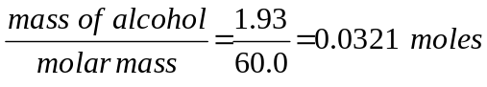

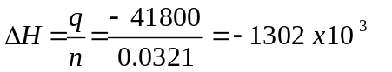J or - 1302 kJ mol⁻¹ (1 mark)

(b) The reference value (literature value) of the heat of combustion of propanol at 25⁰C is
2003 kJ mol⁻¹. Account for the great difference between the experimental
value and the reference value. 1

A large discrepancy exist between the true value and the experimental value because
instead of the heat passing on to water, most of the peripheral equipment : wire gauze, beaker,etc.,
absorbed a large quantity of the heat. (1 mark)

(c) Explain how the students can increase the validity of this investigation 2

Sample answer: (any of the following)

The student can increase the validity of his/her experiment by calibrating the instrument
that is the actual heat capacity of the calorimeter (which includes all peripheral equipment) is determined and is used to calculate the heat of combustion.

Another way is to minimise heat loss by using heat shield while doing the experiment and using as few of the peripheral equipment that is capable of absorbing heat as possible.

Marking scheme
Criterion | Mark
Any valid method of increasing reliability adequately explained | 2
Statement of a valid method of increasing reliability with no explanation | 1

MARKS

Question 27 (4 marks)

Write two equations to show the reactions involving CFCs and ozone that demonstrate the removal
of ozone from the atmosphere. 4

Outcomes assessed:H1, H4, H9

Criteria | Marks
Two correct equations | 4
One correct equation and correct CFC or ozone | 3
One correct equation | 2
Correct formula for CFC and/or has ozone as a reactant | 1

Sample answer:

CCl₃F → CCl₂F + Cl

and

Cl + O₃ → ClO + O₂

no states required.

Question 28 (2 marks)

Identify two possible sources of contamination of the local town water supply 2

Outcomes assessed: H3
Criteria | Marks
Correctly identifies 2 sources | 2
Correctly identifies one source | 1

Sample answer:

<SAMPLE ANSWER>

Question 29 (4 marks)

The quality of a water sample may be determined by considering by considering a
number of factors. Two of these factors are turbidity and hardness. Explain turbidity and
hardness and give a quantitative test that could be used to measure the level s of hardness or
turbidity in a water sample. 4

Outcomes assessed:

Criteria | Marks
Explain both terms with good description of quantitative test | 4
Explain both terms with poor description of quantitative test | 3
Correctly explains both terms | 2
Explains one term | 1

Sample answer:

Hardness of water refers to its ability or inability to lather with soap. Hard water doesn’t
lather with soap.

Suspended organic and inorganic particles create water turbidity. Turbidity is measured
by determining the percentage of light transmitted through a standard depth. It is
measured in NT units.

Hardness can be measured by precipitating Ca²⁺ with CO₃²⁻ and calculating the initial
[Ca²⁺] in the sample.

Section II Industrial Chemistry
25 marks
Attempt Question 30
Allow about 45 minutes for this section.

Answer the question in a writing booklet provided.
Show all relevant working in questions involving calculations

Question 30 Industrial Chemistry (25 marks) MARKS

(a) The flow diagram summarises the Solvay process.

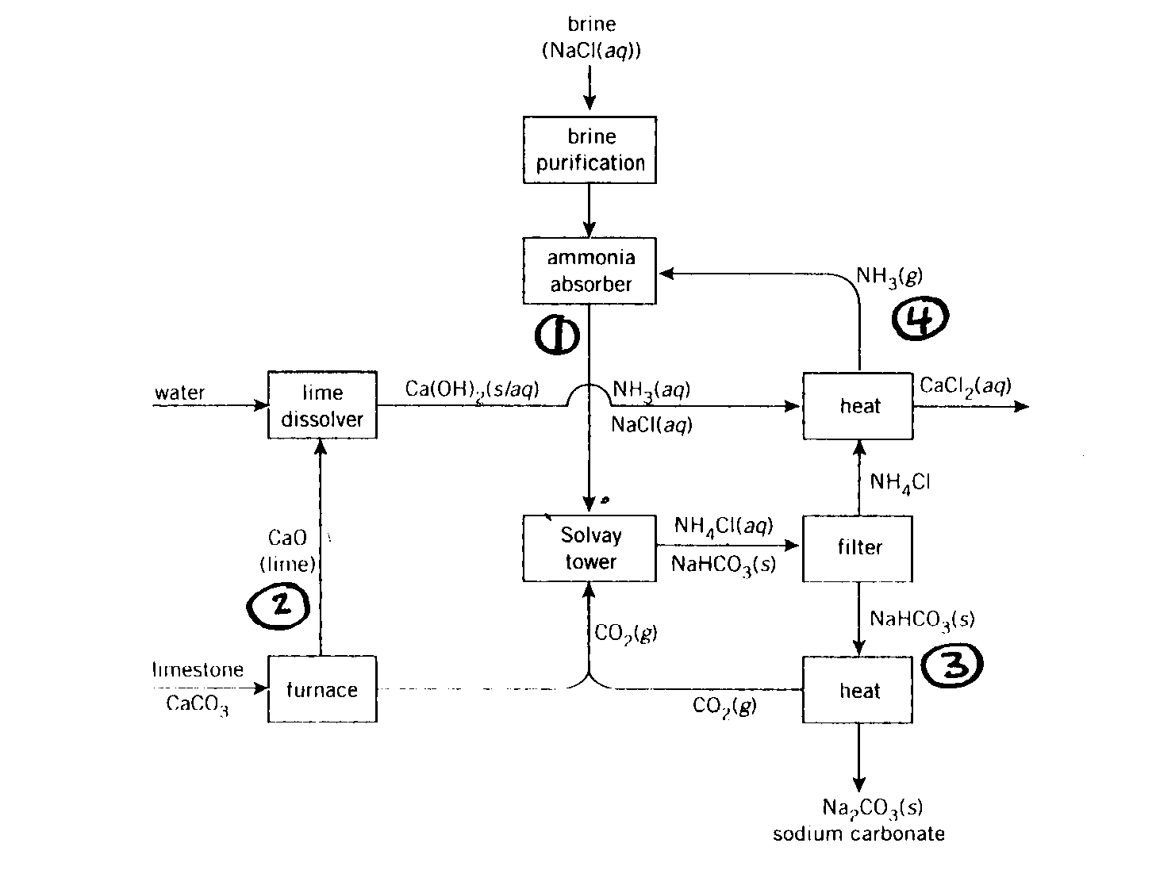

(i) Identify the raw materials used in the Solvay process 1

Outcomes assessed: H8

Criteria | Marks
Correctly identifies the raw materials used in the Solvay process

Sample answer:

sodium chloride and calcium carbonate (brine and limestone)

(ii) Identify the number on the diagram that indicates the ammonia recovery process and
discuss the chemistry involved. 3
Outcomes assessed:H7, H8, H13

Criteria | Marks
Full description, including an equation and identifies process | 3
Any two:describes the process; correct equation; identifies process | 2
Correctly identifies the numbered process | 1

Sample answer:

Ammonia recovery is process 4
Ammonium chloride from the filter combines with calcium hydroxide from the lime kiln to produce ammonia that is recycled. CaCl₂ waste and water.

Ca(OH)₂ + 2 NH₄Cl  CaCl₂ + 2 H₂O + 2 NH₃ (g)

(iii) Discuss the environmental issues associated with the Solvay process 6
and explain how these issues are addressed.

Outcomes assessed: H4, H16

Criteria | Marks
Identifies 3 issues and 3 explanations | 6
Identifies 3 issues but fails to explain all 3 adequately | 5
Identifies 2 issues and 2 explanations | 4
Identifies 3 issues or a combination of issues and explanations | 3
Identifies 2 issues or identifies one issue and explains how it is addressed | 2
Identifies one issue | 1

Sample answer

The major waste product from the Solvay Process is CaCl₂ solution. This can be safely disposed of in the ocean so this problem may be addressed in the initial site location of the plant near the sea. The buffering action of HCO₃⁻ in the sea water can neutralise any residual alkali in the CaCl₂ waste.

Waste heat needs to be disposed of as the overall process is exothermic. Discharge of hot water from the inland plants could lead to thermal pollution so cooling ponds can be used to help dissipate the heat.

Ammonia may be lost to the atmosphere from Solvay plants. It is a significant air pollutant and needs to be monitored carefully to avoid significant losses to the atmosphere.

(b) A key reaction in the manufacture of methanol is

CO (g) + 2 H₂(g)  CH₃OH (g)

(i) This reaction is exothermic. Identify one change that could be made
to increase the yield of methanol. 1

Outcomes assessed: H8

Criteria | Marks
Correctly identifies one change | 1

Sample Answer:
Cool the system or increase the pressure

(ii) A 1L reaction vessel initially contained 0.35 mol CO and 3
0.60 mol H₂. After equilibrium was established, there was only
0.20 mol H₂

Calculate the equilibrium constant for the reaction. Show all
relevant working.
Outcomes assessed: H2,H3,H10,H12,H13

Criteria | Marks
Correct answer with equation and relevant working | 3
Correct equilibrium concentrations and correct expression | 2
Correct equilibrium concentrations or correct expression | 1

Sample answer:

CO + H₂  CH₃OH
0.35 0.60 0
equil 0.15 0.20 0.20

K= 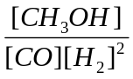

= 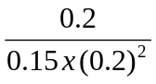

= 33.3

(c) During your practical work you performed a first hand investigation to carry out
saponification and test the product.

(i) Define saponification. 1

Outcomes assessed: H2, H3, H4, H9, H10

Criteria | Marks
Correctly identifies saponification | 1

Sample answer:

Saponification is the hydrolysis of fat or oil under alkaline conditions to produce soap and glycerol.

(ii) Outline the procedure used in your investigation and describe the results
obtained when the product was tested. 3

Outcomes assessed: H11

Criteria | Marks
Good outline and describes results | 3
Good outline of procedure or identifies the procedure and describes results | 2
Identifies the procedure or describes the results obtained | 1

Sample Answer:

20 mL of NaOH solution was added to 5 mL of coconut oil in a beaker. The mixture was gently boiled on a hot plate for 30 minutes, adding water over time to maintain volume. 5g of NaCl was added to help precipitate the soap. After cooling, the soap was filtered out and tested. When the soap was shaken up with tap water, bubbles or frothy foam formed at the top.

(iii) Account for the cleaning action of soap by describing its structure. 4

Outcomes assessed: H2, H3, H4, H9, H10

Criteria | Marks
States reasons for the cleaning action of soaps and describes the structure | 4
States reasons for the cleaning action of soaps | 3
Identifies H₂O solubility of soaps and identifies polar and nonpolar ends of soaps | 2
Identifies H₂O solubility of soaps or identifies polar and non polar ends of soaps | 1

Sample answer:

The way in which soaps clean surfaces can be explained in terms of the solubility of polar and non-polar substances. When soaps dissolve in water, they dissociate into a negatively charged ion, derived from the fatty acid or oil, and a sodium or potassium ion, derived from the alkali used to make it. The negatively charged ion contains a long non-polar hydrocarbon chain, called a hydrophobic end, and a polar carboxylic (COO-) group, which is hydrophilic, and can form hydrogen bonds with water. This negatively charged fatty acid ion is called a surfactant. The hydrocarbon chain strongly attracts non-polar grease molecules, due to dispersion forces, while the hydrophilic end readily dissolves in water. When water is agitated, the oil and grease are removed from the surface being cleaned because they are attached by dispersion forces to the hydrocarbon chain of the surfactant ion. The grease is surrounded by spherical aggregates of surfactant ions whose polar ‘heads’ are directed towards water, while the non-polar ‘tails’ are attached to the grease.

(d) Describe one process used to extract sulfur from mineral deposits and identify one
property of sulfur which allows its extraction in this way. 3

Outcomes assessed: H3, H4, H6,H8, H16

Criteria | Marks
Describes all processes in the extraction of sulfur and identifies one property | 3
Briefly describes the process and identifies one property or describes all processes only | 2
Correctly identifies one property of sulfur that allows for the extraction process. | 1

Sample answer:

Sulfur may be extracted from mineral deposits using the Frasch Process. There are 3 pipes into the sulfur deposit. Superheated H₂O is forced down one pipe, this melts the sulfur and forms a water-sulfur emulsion. Compressed air is forced down another pipe and this in turn forces the water –sulfur emulsion up the third pipe. After cooling, the sulfur is sufficiently insoluble in the water to separate from it. The property of sulfur that allows it to be extracted in this way is its relatively low melting point (113⁰C)

END OF TEST

